Labtask

Output screenshots

1. Aggregation output

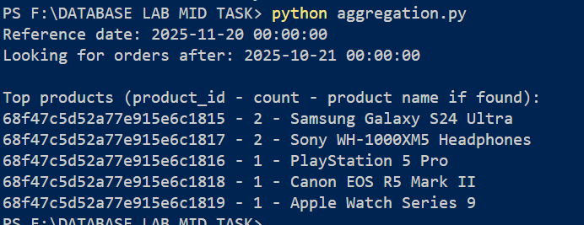

1. Basic api



1. Hybrid search

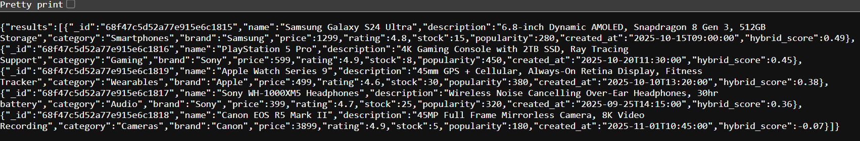

4.keyword search



5. Order

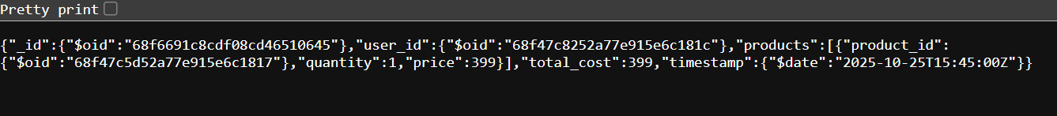6.product review



7.similaity search

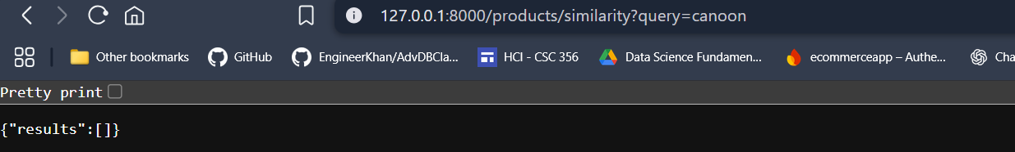

8. User order

